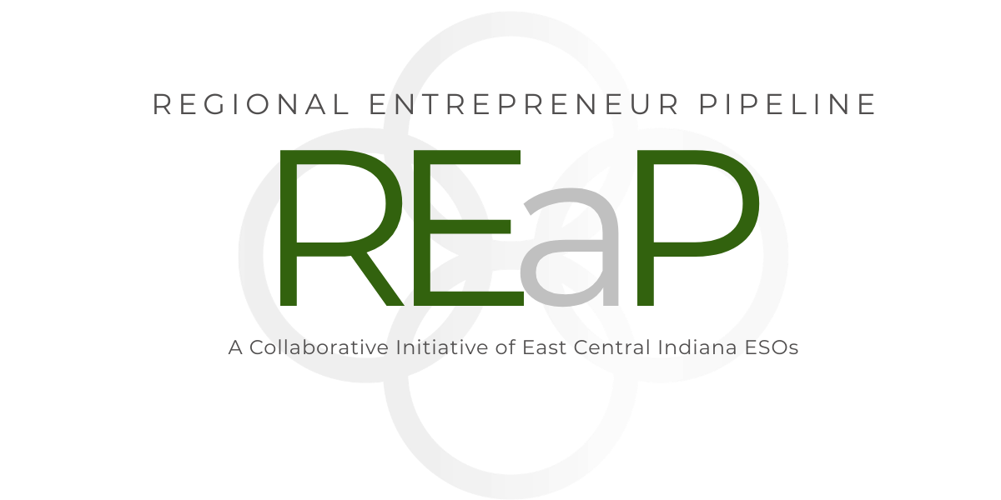
FOR IMMEDIATE RELEASE
Date: July 7, 2026
Contact: Leslie Shaul
Rush County ECDC
(765) 932-5912
lshaul@rushecdc.org

Regional Partners Launch Regional Entrepreneurial Pipeline to Support Small Business Growth
Rushville, Ind. - Rush County Economic & Community Development Corporation, in partnership with Fayette County and Henry County economic development collaborators, is preparing to launch the Regional Entrepreneurial Pipeline (REaP), a regional initiative designed to support new and early-stage entrepreneurs across East Central Indiana.
The program is supported through Indiana's Community Collaboration Fund, administered by the Indiana Economic Development Corporation. The Regional Entrepreneurial Pipeline will provide practical, hands-on support for individuals who have a business idea, operate a side business, recently started a business, or are ready to take the next step toward formal business ownership.
To learn more about the Governor and IEDC announcement and all Community Collaboration Fund grantees, visit: https://events.in.gov/event/gov-braun-strengthens-indiana-entrepreneurship-through-community-grants
The first cohort is scheduled to begin August 13 and will serve participants from Rush, Fayette, and Henry Counties. Weekly sessions will focus on business readiness, banking preparation, marketing, customer identification, pricing, business formation, and local small business resources.
“The Regional Entrepreneurial Pipeline is about meeting entrepreneurs where they are and helping them take practical next steps,” said Leslie Shaul, Workforce Manager for Rush County Economic & Community Development Corporation. “Many people have strong business ideas but are not sure how to move forward. This program is designed to connect them with the information, partners, and support they need to build a stronger foundation.”
The cohort will include sessions led by regional partners, Ivy Tech, local banking professionals, small business resource providers, and subject matter experts. Planned session topics include entrepreneur readiness, banking readiness, marketing, social media, pricing, business formation, LLC registration, EIN setup, INBiz registration, and next-step resources.
A key component of the program will be the Business Formation Lab, which is designed to help eligible participants understand the process of formally organizing their business. Eligible participants may receive assistance with approved LLC registration costs through the program.
The Regional Entrepreneurial Pipeline is intended to strengthen the region's small business ecosystem by helping entrepreneurs better understand the steps involved in launching, organizing, and growing a sustainable business. The program also aims to build stronger connections between entrepreneurs and local support organizations, banks, chambers, technical assistance providers, and economic development partners.
“This is a regional effort,” Shaul said. “Rush, Fayette, and Henry Counties all benefit when local entrepreneurs have better access to practical support, trusted resources, and clear next steps. Our goal is to make the process less overwhelming and more accessible.”
Registration is available online at https://www.rushecdc.org/reap/. Space may be limited, and early registration is encouraged. Questions may be directed to Leslie Shaul at lshaul@rushecdc.org.
###

About Rush County Economic & Community Development Corporation
Rush County Economic & Community Development Corporation works to support business growth, workforce development, community investment, and quality-of-life initiatives throughout Rush County.

About the Regional Entrepreneurial Pipeline
The Regional Entrepreneurial Pipeline is a regional entrepreneur support initiative serving Rush, Fayette, and Henry Counties. The program is designed to help new and early-stage entrepreneurs gain practical knowledge, connect with local resources, and take meaningful steps toward business formation and growth.

About the Community Collaboration Fund

The Community Collaboration Fund (CCF) is a program of the Indiana Economic Development Corporation (IEDC) designed to inspire new, community-led collaborations and programming that drive entrepreneurial education, tech enablement and small business acceleration statewide. CCF grants enable Entrepreneur Support Organizations (ESOs) to implement initiatives that serve Indiana’s entrepreneurs and small businesses and fill critical ecosystem gaps across Indiana’s regions.
Regional Entrepreneurial Pipeline | Rush, Fayette, and Henry Counties

